网上书城

[元数据建模信息有限公司]

|  |
| --- |
| 网上书城 |

文档信息

|  |  |  |  |
| --- | --- | --- | --- |
| 项目名称： | 网上书城 | | |
| 项目经理： | 杨松<yangsong158@qq.com> | 模型编号： | 4.1.1 |
| 模型创建日期： | 2022-7-11 04:21:16 | 模型更新日期： | 2022-7-11 09:23:09 |
| 起草人： | 元数建模自动生成 | 文档创建日期： |  |
| 复审人： | 杨松<yangsong158@qq.com> | 复审日期： |  |
| 项目说明： | 网上书城 | | |
| 官方网站： | <http://www.chiner.com.cn/> | | |
| 开源代码： | <https://gitee.com/robergroup/chiner.git>  <https://gitee.com/robergroup/chiner-java.git> | | |
| 联系作者： |  | | |

# CHINER-网上书城

## 关系图

### ER-[]

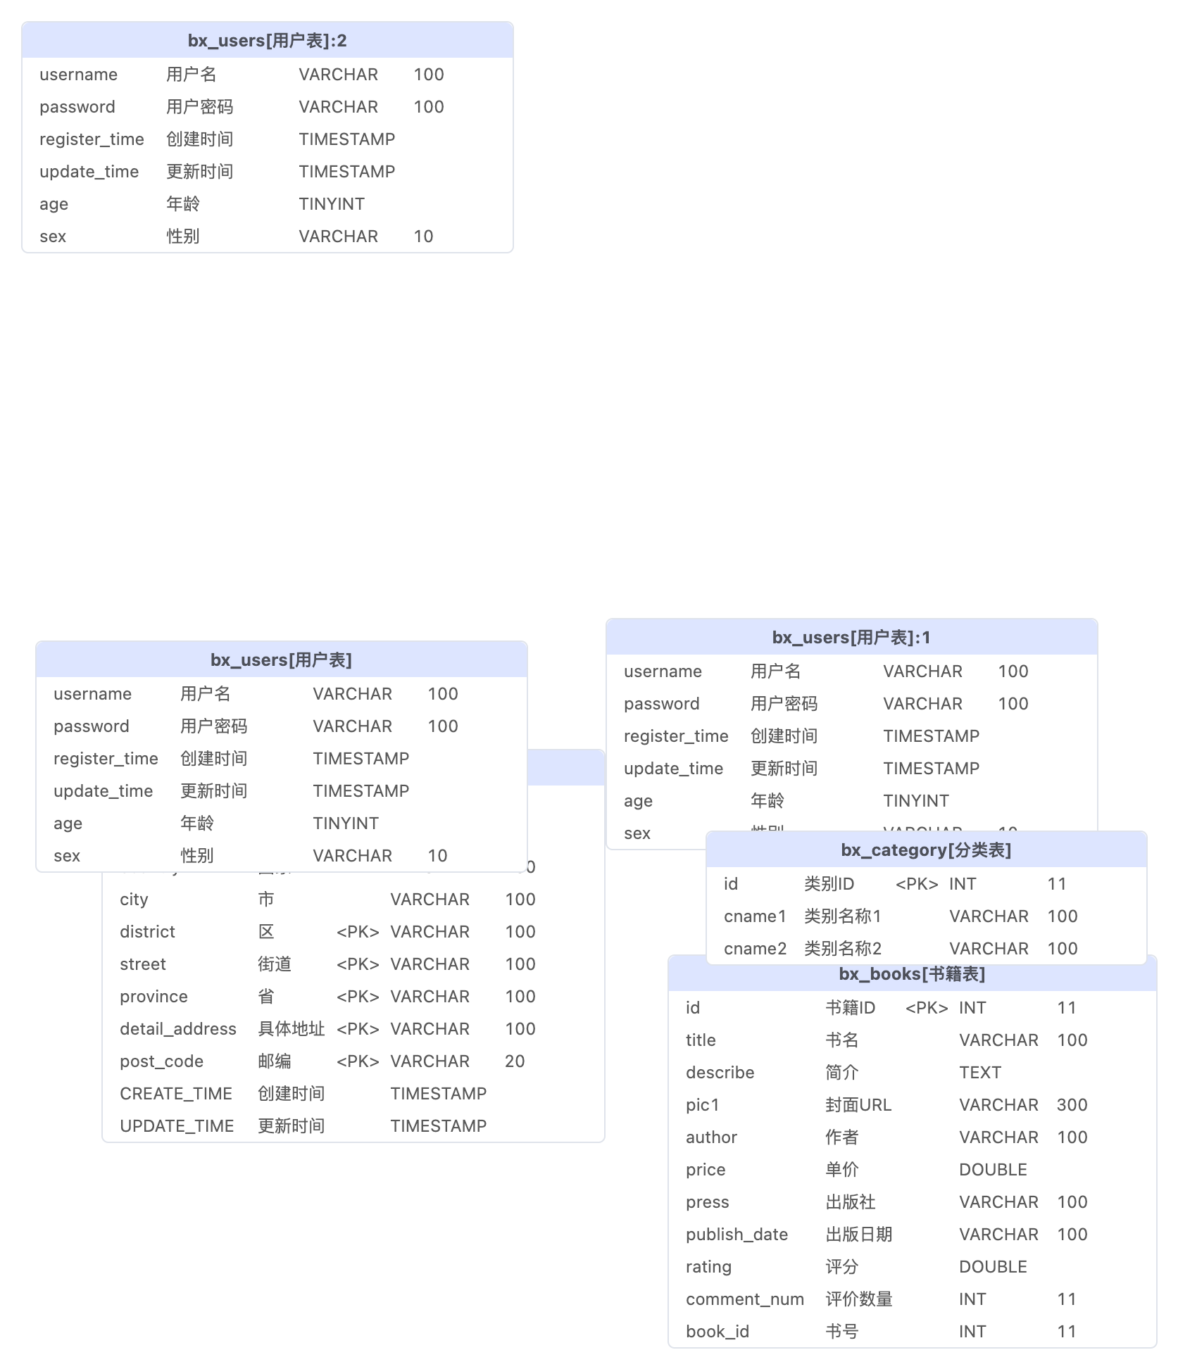

## 表清单

|  |  |  |  |
| --- | --- | --- | --- |
| **#** | **数据表** | **名称** | **备注说明** |
| 1 | bx_users | 用户表 |  |
| 2 | bx_addresses | 收货地址表 |  |
| 3 | bx_orders | 订单表 |  |
| 4 | bx_category | 分类表 |  |
| 5 | bx_books | 书籍表 |  |
| 6 | bx_comment | 评价表 |  |

## 表字段明细

### bx_users [用户表]

|  |  |  |  |  |  |  |  |
| --- | --- | --- | --- | --- | --- | --- | --- |
| **#** | **字段** | **名称** | **数据类型** | **主键** | **非空** | **默认值** | **备注说明** |
| 1 | id | 用户ID | INT(11) | √ | √ |  |  |
| 2 | username | 用户名 | VARCHAR(100) |  | √ |  |  |
| 3 | password | 用户密码 | VARCHAR(100) |  | √ |  |  |
| 4 | register_time | 创建时间 | TIMESTAMP |  | √ | CURRENT_TIMESTAMP |  |
| 5 | update_time | 更新时间 | TIMESTAMP |  | √ | CURRENT_TIMESTAMP |  |
| 6 | age | 年龄 | TINYINT |  |  |  |  |
| 7 | sex | 性别 | VARCHAR(10) |  |  |  |  |

### bx_addresses [收货地址表]

|  |  |  |  |  |  |  |  |
| --- | --- | --- | --- | --- | --- | --- | --- |
| **#** | **字段** | **名称** | **数据类型** | **主键** | **非空** | **默认值** | **备注说明** |
| 1 | id | 地址ID | INT(11) | √ | √ |  |  |
| 2 | uid | 用户ID | INT(11) | √ | √ |  |  |
| 3 | country | 国家 | VARCHAR(100) |  |  |  |  |
| 4 | city | 市 | VARCHAR(100) |  |  |  |  |
| 5 | district | 区 | VARCHAR(100) | √ | √ |  |  |
| 6 | street | 街道 | VARCHAR(100) | √ | √ |  |  |
| 7 | province | 省 | VARCHAR(100) | √ | √ |  |  |
| 8 | detail_address | 具体地址 | VARCHAR(100) | √ | √ |  |  |
| 9 | post_code | 邮编 | VARCHAR(20) | √ | √ |  |  |
| 10 | CREATE_TIME | 创建时间 | TIMESTAMP |  | √ | CURRENT_TIMESTAMP |  |
| 11 | UPDATE_TIME | 更新时间 | TIMESTAMP |  | √ | CURRENT_TIMESTAMP |  |

### bx_orders [订单表]

|  |  |  |  |  |  |  |  |
| --- | --- | --- | --- | --- | --- | --- | --- |
| **#** | **字段** | **名称** | **数据类型** | **主键** | **非空** | **默认值** | **备注说明** |
| 1 | id | 订单ID | INT(11) | √ | √ |  |  |
| 2 | uid | 下单用户ID | INT(11) |  | √ |  |  |
| 3 | status | 订单状态 | INT(11) |  | √ |  |  |
| 4 | order_date | 创建时间 | DATETIME |  | √ | CURRENT_DATETIME |  |
| 5 | update_date | 更新时间 | DATETIME |  | √ | CURRENT_DATETIME |  |
| 6 | add_id | 收货地址ID | INT(11) |  |  |  |  |
| 7 | total_price | 总金额 | DOUBLE |  |  |  |  |

### bx_category [分类表]

|  |  |  |  |  |  |  |  |
| --- | --- | --- | --- | --- | --- | --- | --- |
| **#** | **字段** | **名称** | **数据类型** | **主键** | **非空** | **默认值** | **备注说明** |
| 1 | id | 类别ID | INT(11) | √ | √ |  |  |
| 2 | cname1 | 类别名称1 | VARCHAR(100) |  | √ |  |  |
| 3 | cname2 | 类别名称2 | VARCHAR(100) |  |  |  |  |

### bx_books [书籍表]

|  |  |  |  |  |  |  |  |
| --- | --- | --- | --- | --- | --- | --- | --- |
| **#** | **字段** | **名称** | **数据类型** | **主键** | **非空** | **默认值** | **备注说明** |
| 1 | id | 书籍ID | INT(11) | √ | √ |  |  |
| 2 | title | 书名 | VARCHAR(100) |  |  |  |  |
| 3 | describe | 简介 | TEXT |  |  |  |  |
| 4 | pic1 | 封面URL | VARCHAR(300) |  |  |  |  |
| 5 | author | 作者 | VARCHAR(100) |  |  |  |  |
| 6 | price | 单价 | DOUBLE |  |  |  |  |
| 7 | press | 出版社 | VARCHAR(100) |  |  |  |  |
| 8 | publish_date | 出版日期 | VARCHAR(100) |  |  |  |  |
| 9 | rating | 评分 | DOUBLE |  |  |  |  |
| 10 | comment_num | 评价数量 | INT(11) |  |  |  |  |
| 11 | book_id | 书号 | INT(11) |  |  |  |  |

### bx_comment [评价表]

|  |  |  |  |  |  |  |  |
| --- | --- | --- | --- | --- | --- | --- | --- |
| **#** | **字段** | **名称** | **数据类型** | **主键** | **非空** | **默认值** | **备注说明** |
| 1 | id | 评价ID | INT(11) | √ | √ |  |  |
| 2 | uid | 用户ID | INT(11) |  | √ |  |  |
| 3 | book_id | 书号 | INT(11) |  | √ |  |  |
| 4 | CREATED_TIME | 评价时间 | TIMESTAMP |  | √ | CURRENT_TIMESTAMP |  |
| 5 | content | 评价内容 | TEXT |  |  |  |  |
| 6 | rating | 评分 | DOUBLE |  |  |  |  |

## 数据字典明细

### status [订单状态]

|  |  |  |  |
| --- | --- | --- | --- |
| **#** | **代码** | **名称** | **备注说明** |
| 1 | 0 | 已下单 |  |
| 2 | 1 | 已付款 |  |
| 3 | 2 | 已发货 |  |
| 4 | 3 | 已收货 |  |
| 5 | 4 | 已评价 |  |